# PowerShell ISE

PowerShell ISE (Integrated Scripting Environment) was a scripting editor and **development environment** for PowerShell.

You can run commands. You can also write, test, and debug scripts. ISE provides multiline editing, tab completion, syntax highlighting, selective execution, context-sensitive help, etc.

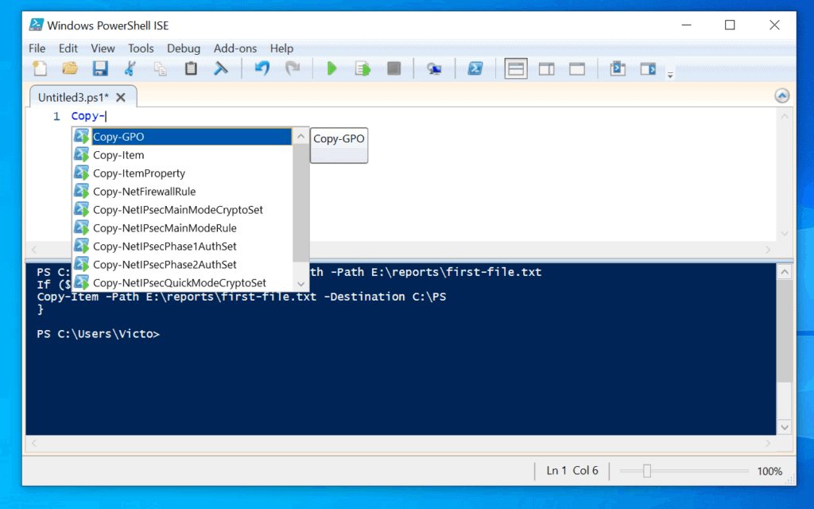

**WARNING**:

Starting from Windows 10 build 1903, PowerShell ISE is no longer being actively developed or updated.

Microsoft recommends using the newer PowerShell 7 which supports PowerShell Integrated Console (PSReadLine), in combination of the PowerShell extension on Visual Studio Code.

If your Window version doesn't have PowerShell 7, you can install the latest version by running:

$ winget install --id Microsoft.Powershell --source winget

# PSReadLine

PSReadLine provides a powerful command-line experience for the PowerShell console. It provides:

* **Syntax highlighting**
* Visual indication of **syntax errors**
* **Predictive** **IntelliSense**:
  + It's disabled by default. To enable it, run: Set-PSReadLineOption -PredictionSource History
* Better multi-line experience (both editing and history)
* Customizable key bindings
* Cmd and Emacs modes
* Many configuration options
* Bash style completion (optional in Cmd mode, default in Emacs mode)
* Emacs yank/kill-ring
* PowerShell token based "word" movement and deletion
* Dynamic display of Help in the console without losing your place on the command line
  + By pressing F1 after typing the command

More details: <https://learn.microsoft.com/en-us/powershell/module/psreadline/about/about_psreadline?view=powershell-7.3>

# PowerShell vs Command Prompt

## Comparison

|  |  |
| --- | --- |
| **PowerShell** | **Command Prompt** |
| Introduced in 2006. | Introduced in 1981. |
| Operate with both **batch commands** and **PowerShell cmdlets**. | Work only with Batch commands. |
| Allow **aliases** for cmdlets or scripts. | Doesn’t support aliases of commands. |
| Output from a cmdlet can be passed to other cmdlets. | Output from a command can’t be passed on to other commands. |
| Output is in the form of an **object** | Output from a command is just **text**. |
| Can execute a sequence of cmdlets put together in a script. | In cmd, a command must be finished before the next command is run. |
| Help command is available to get information regarding any cmdlets. | No such help option is available for information regarding commands. |
| Has an ISE. | Has only a command-line interface, no ISE. |
| Has access to programming libraries as it's built on .NET framework. | No such access to libraries. |
| Can integrate directly with WMI. | Need some external plugins for WMI interaction. |
| Supports **Linux** Systems.  Note: Not all Linux commands are available (e.g. "grep") or function exactly as they do in a native Linux. | Doesn’t support Linux systems. |
| Can be used to run all types of programs. | Can run only console-type programs. |

## Summary

PowerShell is a more advanced version of Command Promt. It's not only an interface but also a scripting language that is used to carry out administrative tasks more easily. Also, most of the commands executed on Command Promt can be run on PowerShell as well.

So, there is **NO reason why we should not use PowerShell** now and forever.